

**Customer Personality Analysis**

**Prepared by: Sayed Said Sayed**

**Mohamed Moustafa Mahmoud**

**Moataz Mohamed Fares**

**Sadek Ali Sadek**

**Supervised by: Eng.** **Marwan Mokhtar**

**Course:** Microsoft Power BI

**Content:**

* Introduction

* Importance of the Project

* Dataset

1. Background about the dataset
2. Meta Data
3. Exploratory and Cleaning

* Business question and Analytical SQL queries
* Entity Relationship Diagram
* Dashboard (Power BI)
* Conclusion& Recommendations

**Introduction**

A Detailed Analysis of a Company’s Ideal Customers Seeks to Analyze Customer Data and Identify Distinct Personality Traits That Influence Purchasing Behavior. This Analysis Aims to Enhance Marketing Strategies, Improve Customer Engagement, and Drive Sales by Aligning Products and Messaging with Customer Personalities.  
It helps a business to better understand its customers and makes it easier for them to modify products according to the specific needs, behaviors, and concerns of different types of customers.

**Importance of the Project**

could be centered around customer segmentation and behavior analysis. The goal would be to highlight:

1. What different customer segments (based on age, education, marital status) behave in terms of spending on various product categories.
2. Which channels are most popular among different customer groups.
3. The effectiveness of promotional campaigns and how they influence customer purchases.
4. The relationship between household composition and purchasing habits.
5. Customer Segmentation and Behavior Analysis based on demographics and purchasing behavior to understand who the key spenders are and how different groups respond to promotions and channels.

By understanding and analyzing these points, we can maximize profits and increase orders.

**Background about the dataset**

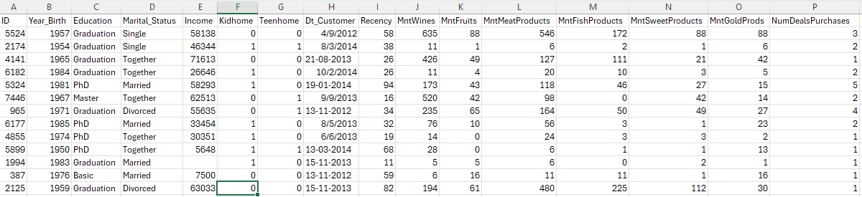

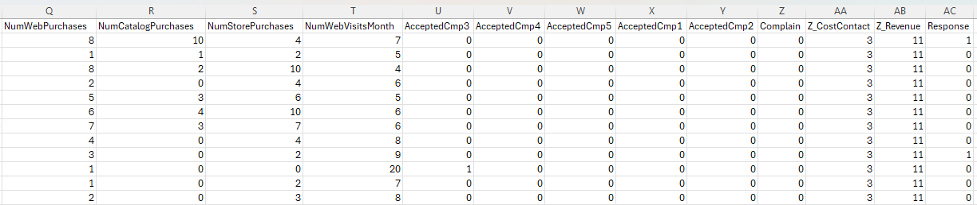

**Meta Data**

Attributes

People

* 1. ID: Customer's unique identifier
  2. Year_Birth: Customer's birth year
  3. Education: Customer's education level
  4. Marital_Status: Customer's marital status
  5. Income: Customer's yearly household income
  6. Kidhome: Number of children in customer's household
  7. Teenhome: Number of teenagers in customer's household
  8. Dt_Customer: Date of customer's enrollment with the company
  9. Recency: Number of days since customer's last purchase
  10. Complain: 1 if the customer complained in the last 2 years, 0 otherwise

Products

1. MntWines: Amount spent on wine in last 2 years.
2. MntFruits: Amount spent on fruits in last 2 years.
3. MntMeatProducts: Amount spent on meat in last 2 years.
4. MntFishProducts: Amount spent on fish in last 2 years.
5. MntSweetProducts: Amount spent on sweets in last 2 years.
6. MntGoldProds: Amount spent on gold in last 2 years.

Promotion

1. NumDealsPurchases: Number of purchases made with a discount.

* AcceptedCmp1: 1 if customer accepted the offer in the 1s campaign 0 otherwise.
* AcceptedCmp2: 1 if customer accepted the offer in the 2nd campaign, 0 otherwise.
* AcceptedCmp3: 1 if customer accepted the offer in the 3rd campaign, 0 otherwise.
* AcceptedCmp4: 1 if customer accepted the offer in the 4th campaign, 0 otherwise.
* AcceptedCmp5: 1 if customer accepted the offer in the 5th campaign, 0 otherwise.
* Response: 1 if customer accepted the offer in the last campaign, 0 otherwise

Place

1. NumWebPurchases: Number of purchases made through the company’s website.
2. NumCatalogPurchases: Number of purchases made using a catalogue.
3. NumStorePurchases: Number of purchases made directly in stores.
4. NumWebVisitsMonth: Number of visits to company’s website in the last month

**Data Exploratory:**

* I understood what each column represents.
* I found outliers in the year birth column.
* The "Marital Status" column contains different values referring to the same thing, such as "alone" and "single," "together" and "married."
* In the "Income" column, there is a value of 666666, which could be a test value rather than a real one. There are also null values in this column.
* The "Customer Registration Date" column has inconsistent date formats.

**Cleaning:**

* When I opened the data in Excel, it appeared all in one row. The solution: I used split columns to separate the columns.
* I cleaned the data using Power Query.
* I removed the outliers.
* In the "Marital Status" column, I changed "alone" to "single" and "together" to "married."
* I deleted the row with the value 666666.
* I fixed the date formatting by changing all delimiters to "/", then split the date into three columns, and later recombined them.
* I filled the null values in the "Income" column with the average value.
* I deleted the "yolo" and "absurd" entries.
* I made a normalization to improve the performance and Facilitate comparison.

**Business question and Analytical SQL queries**

ERD diagram

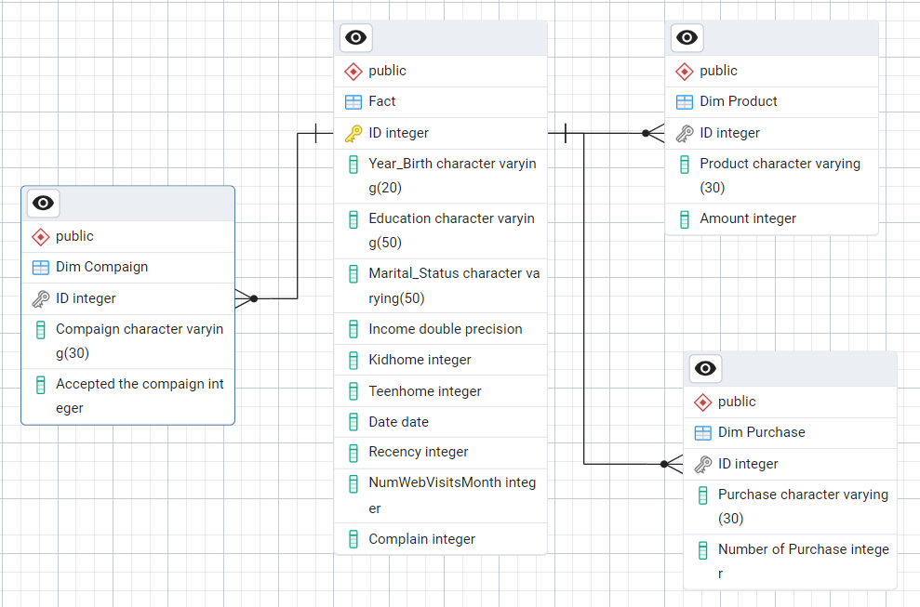

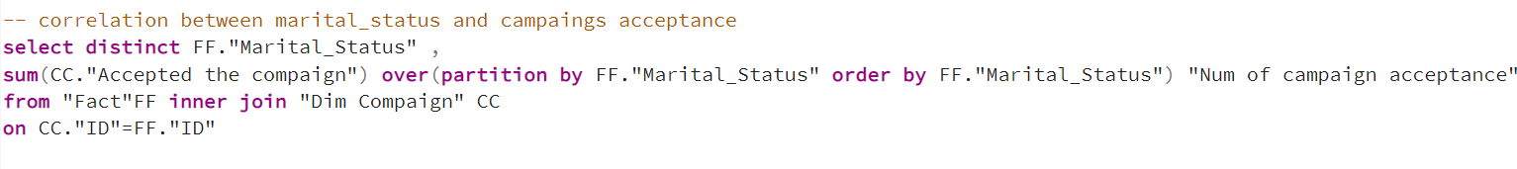

Business Meaning:

Analyzing the correlation between marital status and campaign acceptance involves examining whether customers' relationship status (e.g., single, married, divorced) has any influence on how likely they are to respond positively to marketing campaigns. A high correlation indicates that marital status is a significant factor in determining campaign success, while a low or no correlation suggests that it may not be a crucial factor.

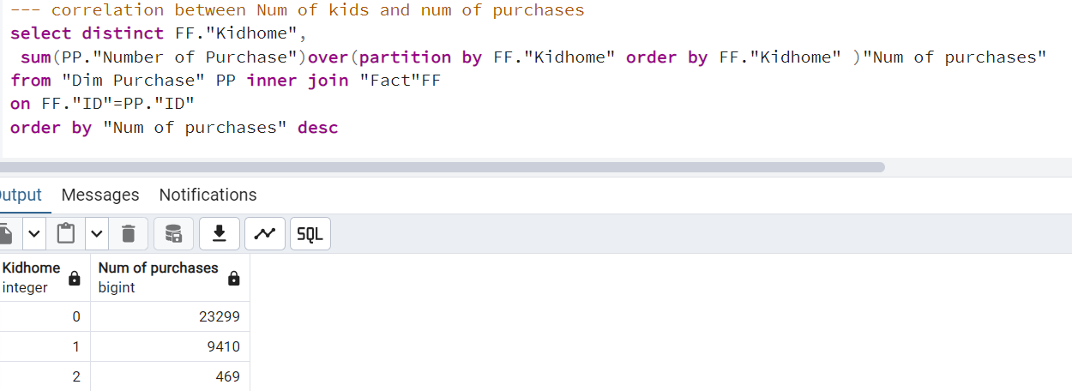

Business Meaning:

Negative Correlation: If there is a negative correlation, it means that as the number of kids increases, the number of purchases decreases. This might suggest that families with more kids are more budget-conscious or make fewer purchases because of financial constraints.

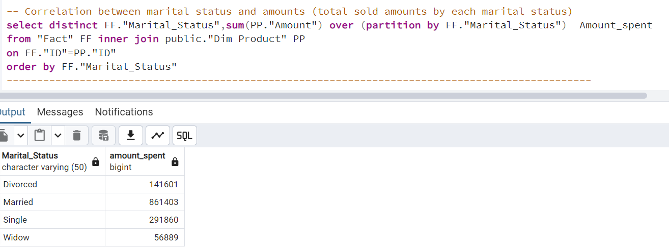

Business Meaning: When analyzing the correlation between marital status and the amounts spent by customers, we are trying to understand how a customer’s marital status (e.g., single, married, divorced, widow) influences their spending behavior.

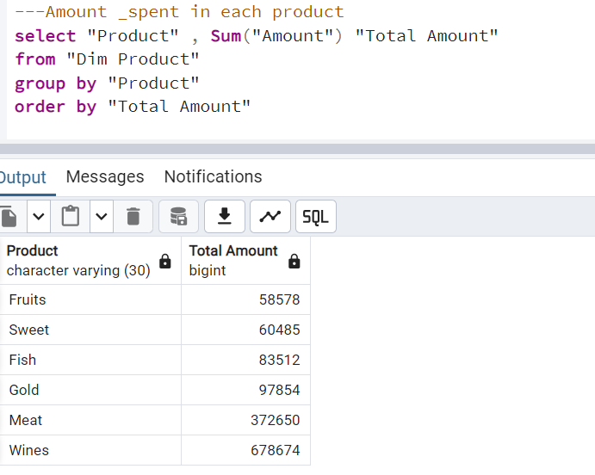

Business Meaning: Amount spent in each product to know most product get revenue

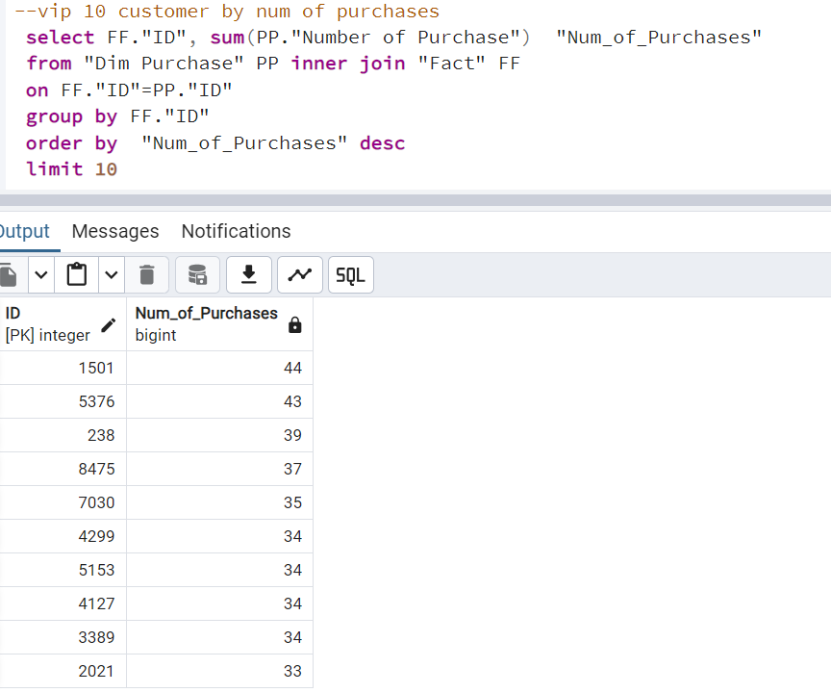

Business Meaning:

VIP customers, especially those with large orders, are typically high-value customers who contribute significantly to a company’s revenue

Business Meaning: Knowing the buying behaviors of each age group and the number of customers in each age group

Targeted Marketing Based on Age Group:Young Group: Since they have lower purchasing activity, create targeted promotions or discounts to attract more young customers. Highlight products like Sweet and Meat, which already show some interest from younger customers.

Business Meaning:

This table represents the number of interactions (accepted responses) for various marketing campaigns. The "Campaign" column lists the campaign names, while the "total accepted" column shows the number of times customers accepted or responded positively to these campaigns. The campaigns are ordered by the highest number of accepted responses.

Business Meaning:

This SQL query and the resulting table analyze the number of accepted responses to campaigns and the number of purchases categorized by different income ranges. The three income categories

Business Meaning

The SQL query you provided calculates the total number of accepted campaigns for each education level. This information can be valuable for understanding the relationship between education and campaign success.

Business Meaning

The SQL query calculates the average recency (time since last purchase) for different customer age groups. This information can help you understand the relationship between customer age and purchase behavior.

Business Meaning

The SQL query calculates the total amount spent by each customer on different products and ranks the products based on the spending amount. It then filters the results to show only the top two products for each customer.

Business Meaning

The SQL query calculates the average income and average amount spent by customers based on their marital status. This information can help you understand the relationship between marital status and customer spending behavior.

: The SQL query calculates the number of customers in each recency segment and their percentage from the total customer base. This information can help you understand the distribution of customer activity levels and identify areas for improvement.

Business Meaning Purpose: The SQL query aims to analyze the total number of purchases made across different purchase types (Store, Web, Catalog, Deals).

Business Meaning : Purpose: The SQL query aims to analyze the relationship between income range and online purchasing behavior, specifically focusing on the number of web visits and purchases made.

Business Meaning : Purpose: The SQL query aims to analyze the sales performance of different products across various Kid home stores. It calculates the total purchase amount for each product and its percentage contribution to the total sales of that Kid home.

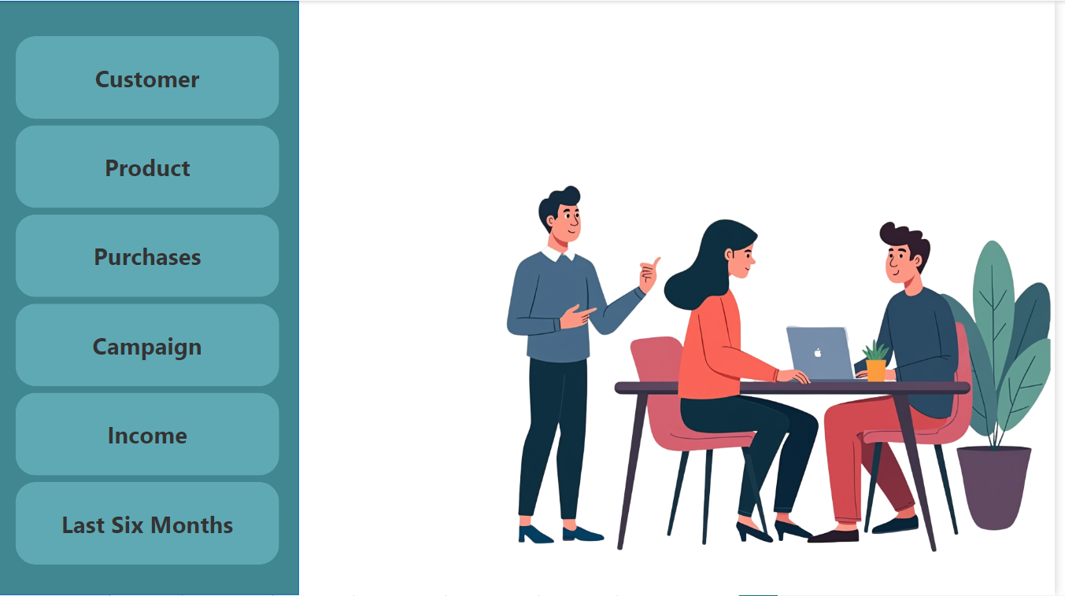**Dashboard (Power BI)**

**1-** This First Page represents a conceptual layout where different data categories are highlighted. The left side lists categories such as:

1. Customer: Referring to customer information (Recency, Loyalty, Education, Marital Status).
2. Product: Data on the products customers are interacting with or purchasing.
3. Purchases: Information on transaction history, including items bought, frequency, and value.
4. Campaign: Refers to marketing or promotional campaigns targeted toward customers.
5. Income: Related to customers' income data or the revenue generated from sales.
6. Last Six Months: Data covering customer behavior or sales trends in the last six months

**2-** A Dashboard aggregating customer metrics and insights.

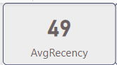

Avg Recency: Average no. of days since the last customer interaction.

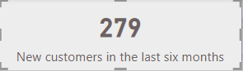

New customers in the last six months**:** Indicates the number of customers acquired recently.

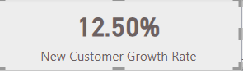CALCULATE ([Total Customers], 'Fact Customer'[Registration

Date]> DATE (2014, 3, 31))

New Customer Growth Rate: Measures the growth in new customers as a percentage.

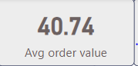 [New customers in the last six months] / [Total Customers]

Avg Order Value: The average value of customer orders.

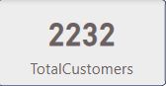 [TotalAmount_spent] / SUM(Dim_purchase[Number of

Purchase])

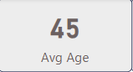 **Total Customers:** Total number of customers in the dataset.

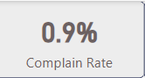 Avg Age: The average age of customers.

Complain Rate: Percentage of customers who filed complaints.

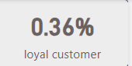sum('Fact_Customer'[Complain])/COUNT('Fact_Customer'[Complain])

Loyal Customer: The proportion of customers categorized as loyal.

DIVIDE(CALCULATE([TotalCustomers],Dim_purchase[Number of Purchase]<=MAX(Dim_purchase[Number of Purchase]) && Dim_purchase[Number of Purchase]>=MAX(Dim_purchase[Number ofPurchase])*.7 ,'Dim product'[Amount]>AVERAGE('Dim 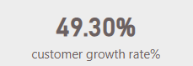product'[Amount])),[TotalCustomers])

Customer Growth Rate: Shows a high-level percentage of customer growth over a given period, increasing in the customer base.

DIVIDE([var_LY_customer],[LY_customer])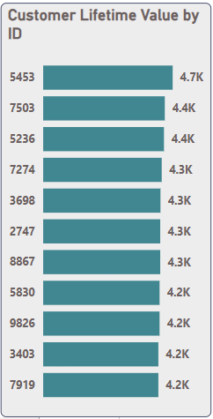

Customer Lifetime Value by ID: Displays the customer lifetime value (CLV) for different customer IDs, showing which customers have generated the most value over their relationship with the company.

* + - 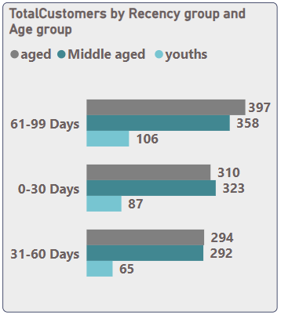CLV**:** [Avg order value]*[Purchase Frequency]*[CustomerLifespan]

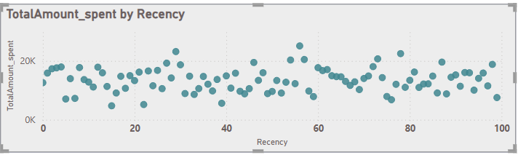Total Customers by Recency group and Age group: Breaks down customer recency into groups and compares it across age groups.

Total Amount Spent by Recency: Recency & Total amount spent by customers

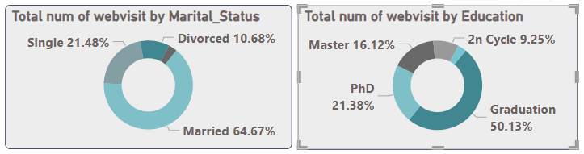

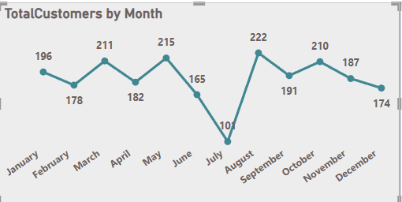Total num of web visits by Marital Status & Total num of web visits by Education: Those two pie charts show the percentage of website visits by marital status, most visits come from married customers (64.67%). In Addition to Web visits are segmented by education levels, most visits are from customers who have graduated (50.13%).

Total Customers by Month: This line chart tracks the total number of customers by month. There is some fluctuation with peaks in May and August, showing the highest customer counts.

* + - The Calculation: CALENDAR("30-7-2012","10-6-2014")

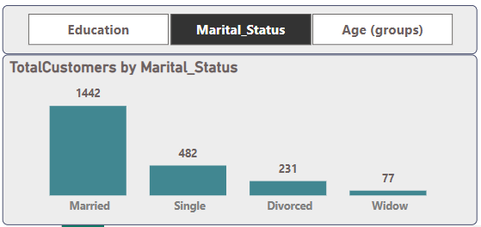

1. **Total Customers by Marital Status**: Shows the number of customers segmented by their marital status. Most customers are married (1442).

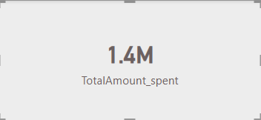Total customer by Marital_status, age, education, and product categories.

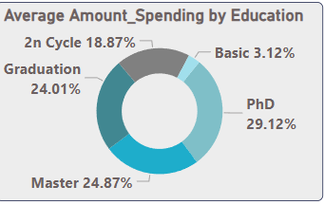Total Amount Spent :The total amount spent by customers across all categories is 1.4 million, which serves as the primary metric to evaluate customer spending behavior.

Average Amount Spending by Education

* PhD (29.12%): The highest spending group.
* Master (24.87%) and Graduation (24.01%): Also significant contributors to total spending.
* 2nd Cycle (18.87%) and Basic (3.12%): Spend comparatively less.

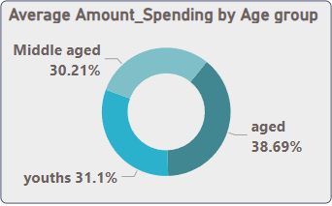

Average Amount Spending by Age Group (Pie chart)

* Aged (38.69%): The most significant age group in terms of spending.
* 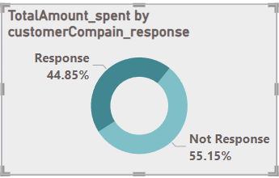Middle-aged (30.21%) and Youths (31.1%): Show similar spending patterns, with a slightly higher percentage for the youth segment.

Total Amount Spent by Customer Complain Response

* Response (44.85%): Customers who responded to complaints account for a significant portion of spending.
* Not Response (55.15%): The majority of spending comes from customers who did not respond, possibly indicating that complaint resolution could be improved.
* The Measure: IF(Fact_Customer[CompaignValue]=1,"Response","Not Response"

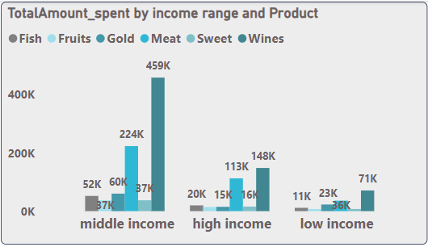 Total Amount Spent by Income Range and Product

* Middle Income: Contributes the most to spending (459K), particularly on gold and fish.
* 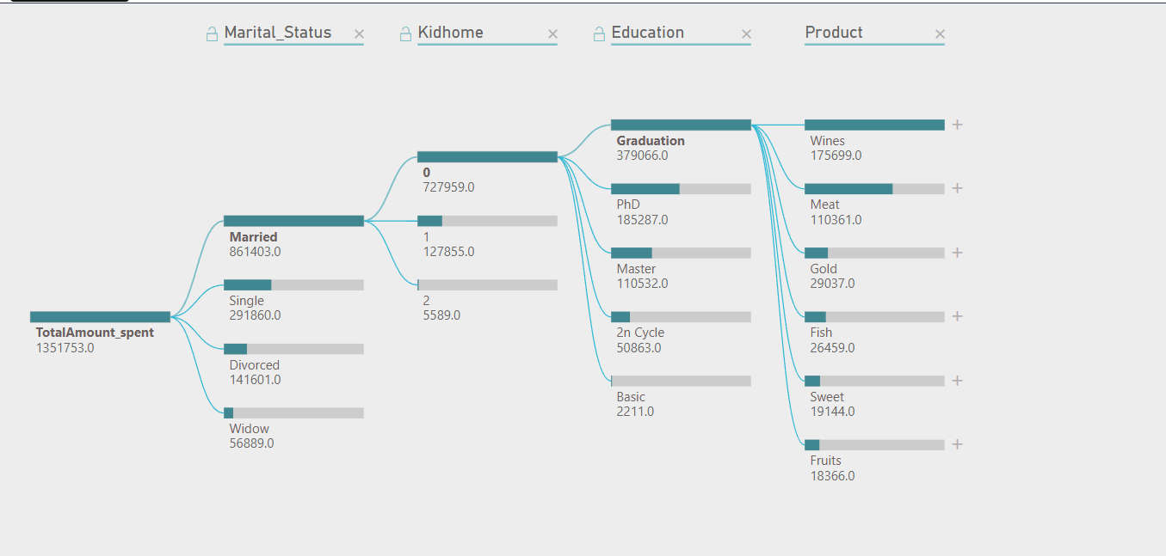High Income: Spends heavily on fruits and wine (224K).
* Low Income: Spends the least, with only small amounts spent across all categories.

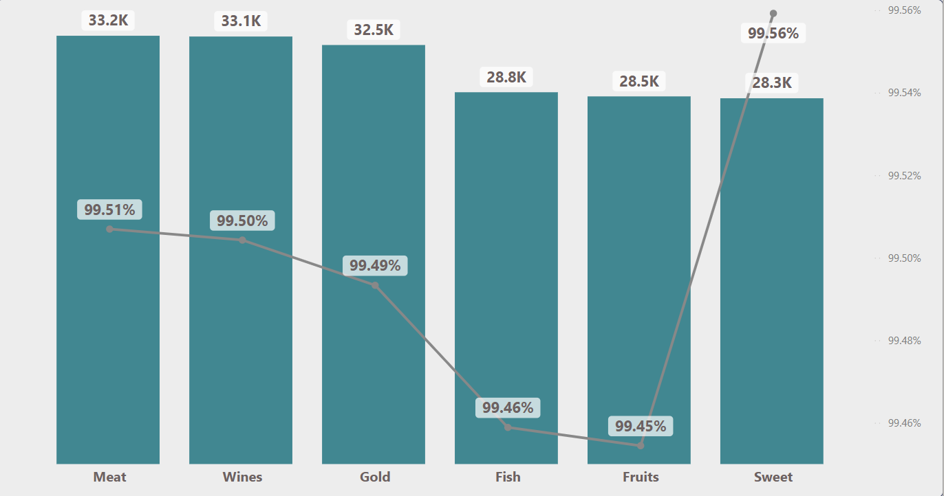Marital Status and Education Flow**:** Married customers have the highest total amount spent, followed by single and divorced. This implies married customers are the primary contributors to spending. The presence of children increases spending, particularly on education-related products.

Total Purchases and Repeat Purchasing Rate by Product

* Meat, Wines, Gold, Fish, Fruits, Sweet: All show high repeat purchasing rates (99.5%+). This indicates high customer loyalty across all product categories.
* Sweet has the highest repeat purchase rate (99.56%).

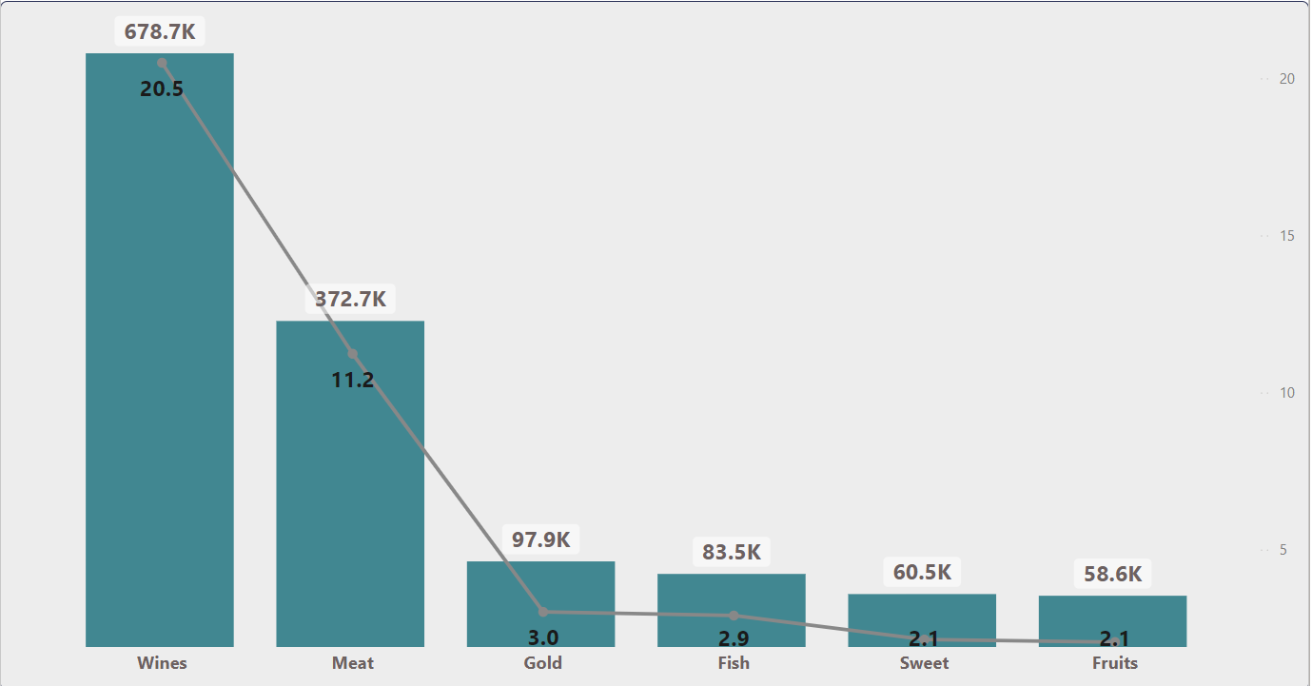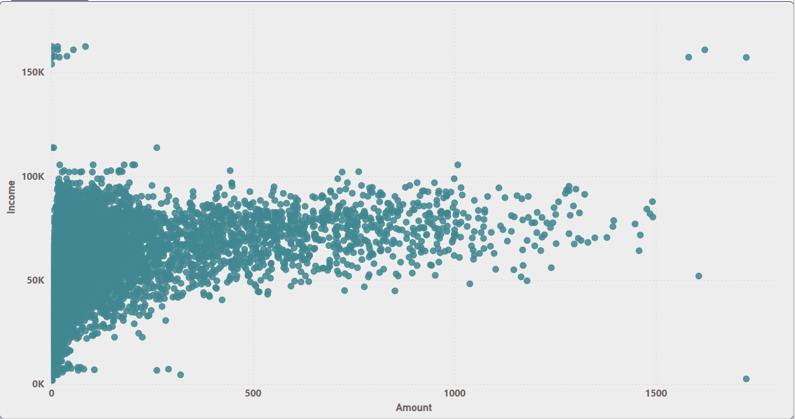Amount and Income:Displays the relationship between total amount spent and customer income. It shows high-income customers spending significantly more.

Total Amount Spent and AOV (Average Order Value) by Product

* Wines (678.7K): The product with the highest total spending, followed by Meat (372.7K).
* Fruits (58.6K) and Sweet (60.5K) have lower total spending but still maintain high repeat rates.
* The Measure: TotalAmount_spent] / SUM(Dim_purchase[Number of Purchase])

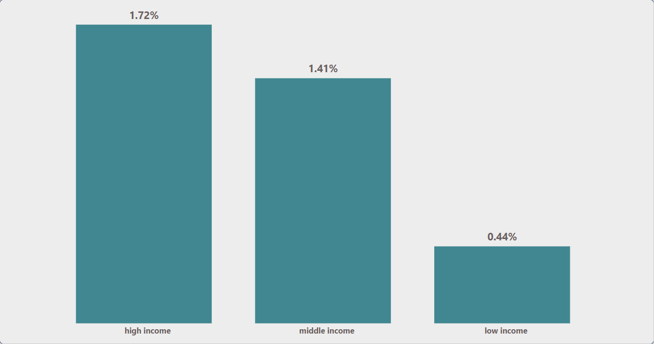

Percent of Amount Spent from Income by Income Range

* High income (1.72%): This group spends a higher percentage of their income compared to middle-income (1.41%) and low-income (0.44%) groups.

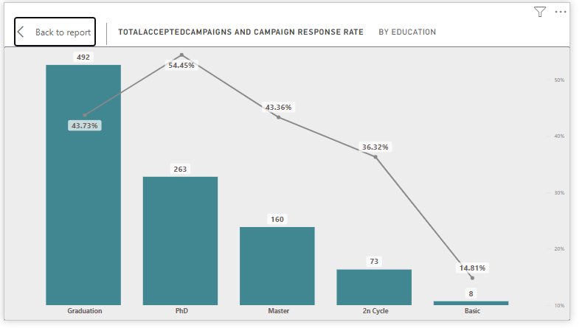

-This is a bar and line chart titled "TOTAL ACCEPTED CAMPAIGNS AND CAMPAIGN RESPONSE RATE BY EDUCATION." It compares the number of total accepted campaigns (represented by bars) and the campaign response rate (represented by a line) across different education levels.

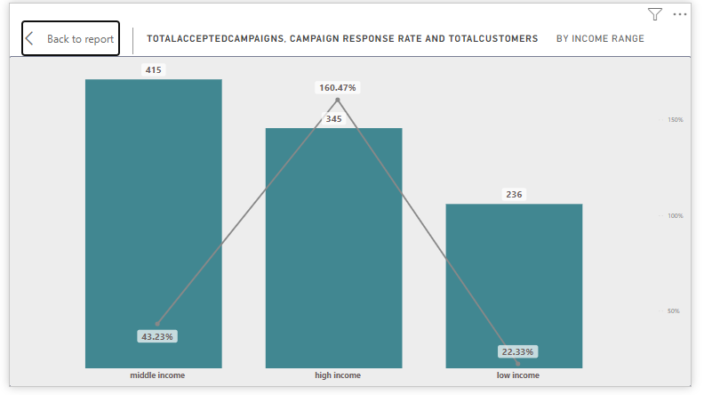

-This is a bar and line chart titled "TOTAL ACCEPTED CAMPAIGNS, CAMPAIGN RESPONSE RATE AND TOTAL CUSTOMERS BY INCOME RANGE." It shows data comparing the total number of accepted campaigns (represented by bars) and the campaign response rate (represented by a line) across different income ranges.

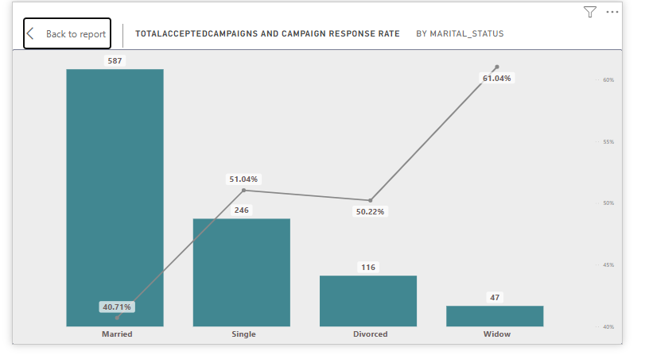

-This is a bar and line chart titled "TOTAL ACCEPTED CAMPAIGNS AND CAMPAIGN RESPONSE RATE BY MARITAL STATUS." It compares the total number of accepted campaigns (represented by bars) and the campaign response rate (represented by a line) across different marital statuses.

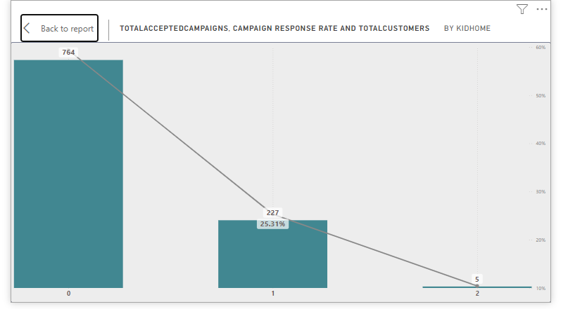

This chart described is a chart that likely presents data related to campaigns conducted by KidHome. It displays three key metrics: the total number of accepted campaigns (764), the campaign response rate (25.31%), and the total number of customers, which is noted as 1

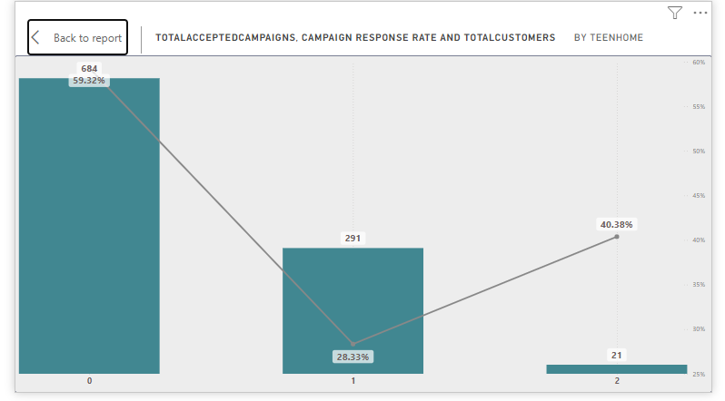

This chart is a diagram displaying data related to campaign performance for "TeenHome." It includes three key metrics: the total accepted campaigns, the campaign response rate (59.32% and 40.38%), and the total number of customers (291 and 21). The information seems to be organized in a way that could represent comparisons between different campaigns or segments within TeenHome.

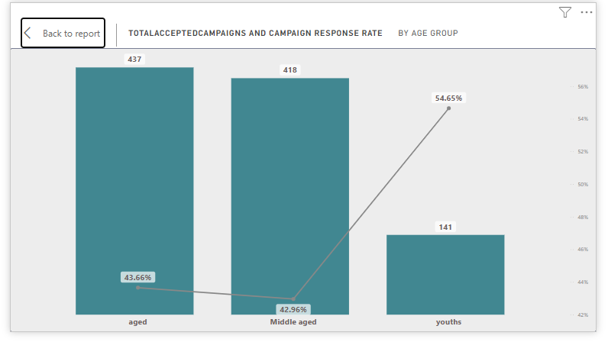

This is a bar chart depicting the total accepted campaigns and campaign response rates categorized by age group. It shows data for middle-aged individuals and youths, with specific numbers: 437 campaigns accepted for middle-aged individuals, 418 for youths, accompanied by respective response rates of 54.65% for middle-aged and 42.96% for youths.

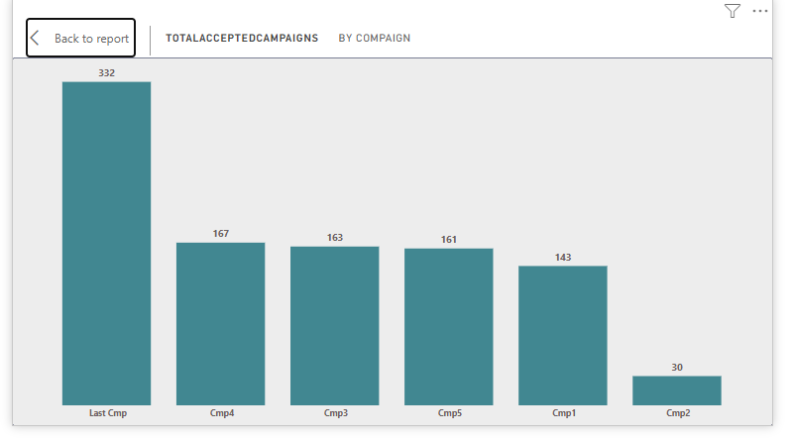

This is a bar chart displaying the number of accepted campaigns categorized by different campaign types. The chart shows four categories: ORE, Last Camp, Cmp, and CmpZ, with the respective total accepted campaigns indicated by values (167, 16, and 161). The layout is rectangular and includes text elements that provide context to the data presented.

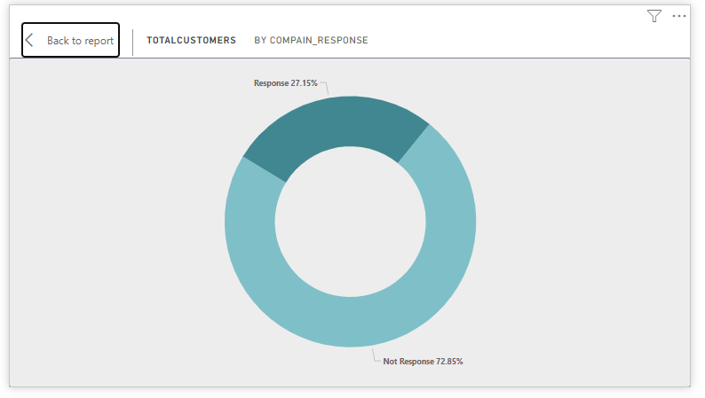

This is a sunburst chart showing customer responses divided into two categories: "Response" and "Not Responded." The "Response" category accounts for 27.15% of the total customers, while the "Not Responded" category makes up 72.85%. It appears to be a screenshot related to software or report design.

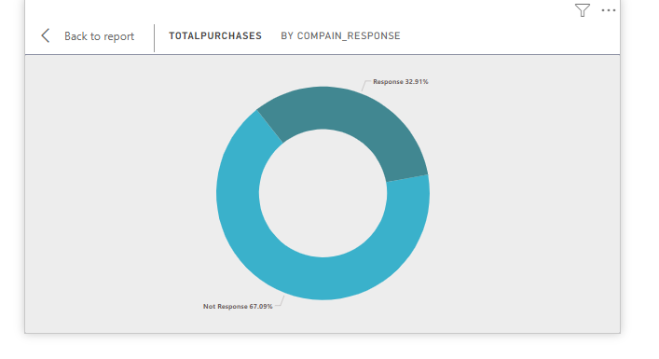

This is a chart displaying the total purchases categorized by company response. It shows that 32.91% of purchases were made in response to a specific company, while 67.29% were made without any response. The chart features numerical percentages and uses a circular design, with clear text and font for easy readability.

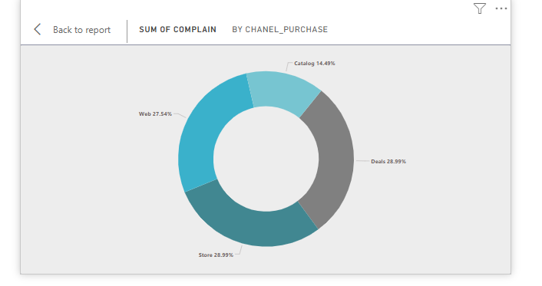

This is a chart titled "SUM OF COMPLAIN BY CHANEL_PURCHASE," which appears to illustrate data related to complaints associated with Chanel purchases. The chart includes figures such as 14.49 and percentages indicating various aspects, such as a decrease of 27.54% for "web" and an increase of 28.59% for "Deals."

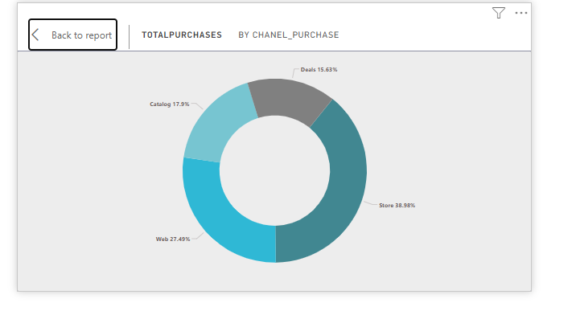This is a chart related to total purchases made by Chanel

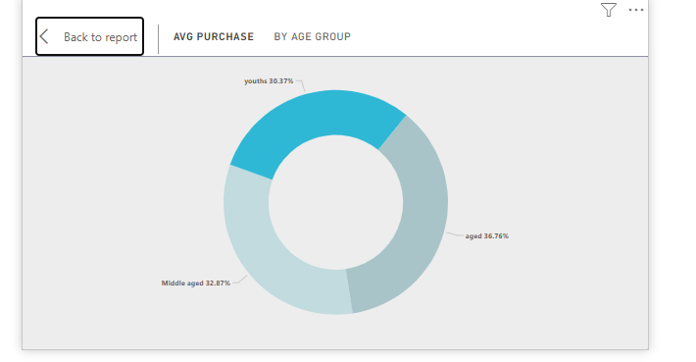This is a sunburst chart illustrating average purchases by age group.

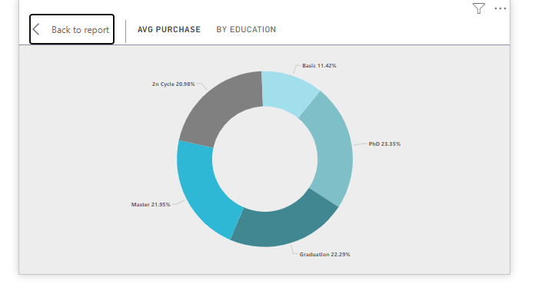

This is a pie chart showing the average purchase by level of education. The pie chart has 6 slices. The largest slice is for "PhD" at 23.35% followed by "Graduation" at 22.29% and "Master" at 21.95%. The other slices are "2nd Cycle" at 20.98%, "Basic" at 11.42% and The title of the chart is "AVG PURCHASE BY EDUCATION".

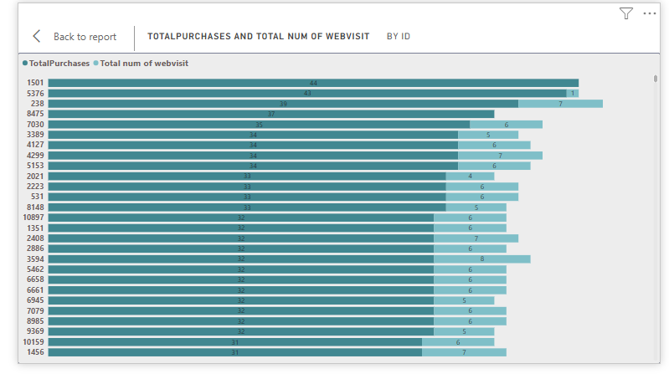

The image is a chart depicting the relationship between total purchases and the total number of web visits by ID.

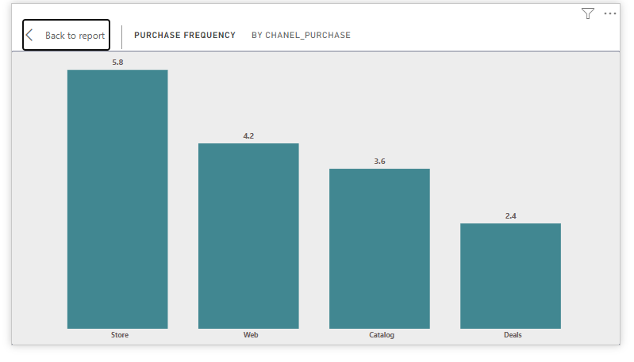

The image shows a bar chart visualizing purchase frequency by channel. The x-axis represents different purchase channels: store, web, catalog, and deals. The y-axis represents purchase frequency, with the highest being 5.8 for the store channel.

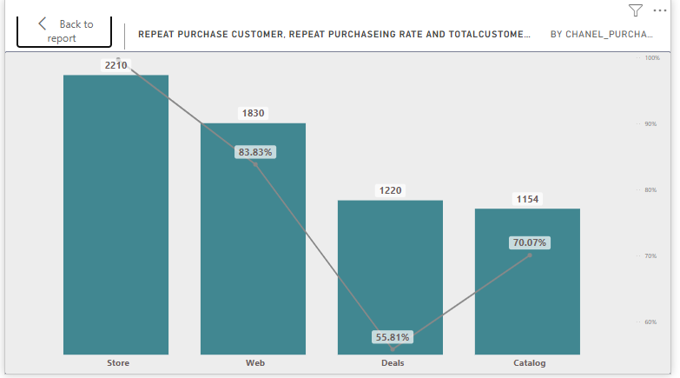

The image shows a bar chart with four bars representing the number of customers acquired through "Store", "Web", "Deals" and "Catalog" channels. The height of each bar represents the number of customers acquired through each channel. The chart also shows the rate of repeat purchasing for each channel represented by a line graph and the percentage of repeat customers displayed on the line. The "Store" channel has the highest number of customers and the highest repeat customer rate of 83.83%, while the "Deals" channel has the lowest repeat customer rate of 55.81%.

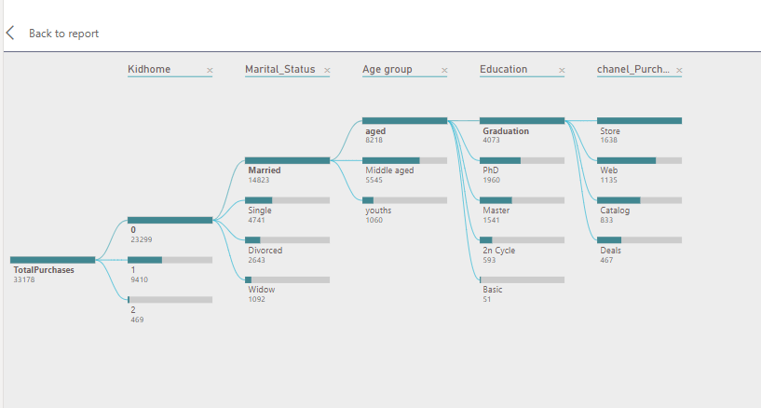

The content describes a chart related to customer behavior, specifically focusing on Chanel purchases. It includes various demographic factors such as marital status (single, married, divorced, widow), age group , and education levels. The chart also seems to categorize the data into different segments

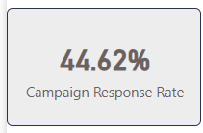

Campaign Response Rate = DIVIDE( SUM('Dim compaign'[Accepted the compaign]), COUNT('Fact_Customer'[ID]) )

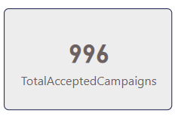TotalAcceptedCampaigns = COUNT('Dim compaign'[Accepted the compaign])

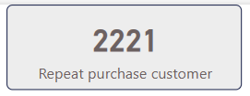

* Count of repeat purchases by customers

Income Page

This Page provides a comprehensive overview of customer demographics, purchasing behavior, and income levels. Key insights include:

* Customer Demographics: The customer base is predominantly middle-aged, with a significant portion of younger individuals. The average income is 51.94K, with a wider range of incomes observed among middle-aged customers compared to youths and the elderly.
* Purchasing Behavior: Customers across all age groups tend to make more frequent purchases as their income increases. The most popular product categories are fish, fruits, and meat, with variations in preferences across income levels.
* Income Distribution: Most customers fall within the middle-income range, followed by the low-income and high-income groups. Within each income group, there are further variations in average income based on age and education level.
* Website Engagement: Website visits are highest among middle-aged customers, followed by youths and the elderly. Income level does not appear to have a significant impact on website engagement.

Overall, this page offers valuable insights into customer segmentation, purchasing patterns, and income distribution, enabling businesses to tailor their marketing strategies and product offerings to meet the specific needs of different customer groups.

The average income of all customers

This chart displays the average income of our customer base. The value 51.94K represents the mean annual income of all customers in our dataset

Relationship between Income and Monthly Website Visits

This chart shows how much people earn and how often they visit our website. Each dot represents one person, with their income on the left and how often they visit on the right.

Total Purchases by Income Range and Product Category

This chart shows how much people in different income groups spend on different products. The products are fish, fruits, gold, meat, sweets, and wine, and the income groups are low, middle, and high. The size of each bar shows how much was spent on each product by each income group.

Average Spending by Income Range

This chart visualizes the average amount spent by each income group, It can be observed that the high-income group accounts for the largest proportion of spending, followed by the middle-income group, and then the low-income group.

Average Purchase Value by Income Range

This chart visualizes the average value of purchases made by individuals in each income group. The percentages in the chart represent the share of total consumer spending for each income group.

Average Income by Age Group

This chart shows how much people earn based on their age. Older people tend to earn more than middle-aged people, and middle-aged people earn more than younger people.

Total Number of Website Visits by Age Group

This chart visualizes the total number of website visits made by individuals in each age group.

Customer Distribution by Birth Year

It can be observed that the middle-aged group accounts for the largest proportion of website visits, followed by the older age group, and then the younger age group.

Customer Distribution by Income Range and Age Group

This chart shows how many customers are in different income groups and age groups. Most customers have middle incomes, but older customers are more likely to be wealthy, and younger customers are more likely to have low incomes.

Average Income by Education Level

This chart shows the average income for people with different education levels. People with higher education levels tend to earn more money than those with lower education levels.

Average Income by Marital Status

This chart shows how much money people earn based on their marital status. Widowed people tend to earn the most, followed by divorced, married, and single people.

Last six months page

This page offers a comprehensive overview of customer activity and performance metrics for the year 2014. Key insights include:

Customer Acquisition:

• A significant increase in new customer acquisition was observed from April to May, followed by a decline in June.

Website Engagement:

• Website visits peaked in May 2014, with a subsequent decrease in June.

• Most website visitors (54.94%) made at least one purchase, indicating a relatively high conversion rate.

Purchasing Behavior:

• Customers with teenagers in their households tended to spend less than those without teenagers.

• The total number of customers and website visits varied across the months, with May experiencing the highest activity.

Overall, this page provides valuable insights into customer behavior, website traffic, and sales performance during the year 2014. Businesses can use this information to optimize their marketing strategies, improve customer acquisition and retention efforts, and identify opportunities for growth.

Monthly Data Selection

This slicer lets you pick from months 1 to 10 to filter the information shown on the Charts and helps you find trends and patterns over specific months.

Year Selection

This slicer lets you pick from the years 2012, 2013, and 2014 to filter the information shown on the Charts and helps you find trends and patterns over specific years.

Purchase Channel Selection

This slicer lets you pick from catalog, deals, store, or web to filter the information shown on the dashboard and helps you see how sales and customer behavior change based on how people buy.

Comparison of Total Website Visits and Total Purchases

This chart compares how many people visit our website to how many people buy something. It shows that almost 55% of website visitors make a purchase, which is a good conversion rate.

Total Amount Spent by Number of Teenagers in Household

This chart shows how much money families spend based on how many teenagers they have. Families with no teenagers spend the most, followed by families with one teenager. Families with two teenagers spend the least.

Monthly Comparison of Total Customers and Website Visits

This chart compares how many customers, and website visits we had each month. The months are May, April, and June. Each bar shows the total number of customers and website visits for each month. This helps us see the relationship between customer activity and website engagement over time.

New Customers Acquired in the Last Six Months

This chart shows how many new customers we got each month for the past six months. We got more new customers in May than in April or June. This information can help us understand what makes people want to become our customers.

Total Number of Website Visits by Year and Month

This chart shows how many people visited our website each month in 2014. More people visited in May than in April or June. This information can help us understand when people are most likely to visit our website.

**Conclusion & Recommendations**

For the last 3 months, I have had no clients.

In the last 6 months, customers have decreased.

People who had a large recency had a large Amount spent.

* **Focus on Married Customers**: Since 64.67% of the customers are married, tailor campaigns specifically for this segment to increase engagement and retention.
* **Increase Engagement for Youths**: The youth segment (0-30 days) has the lowest number of customers. Implement campaigns focused on this age group.
* **Target Graduates**: 50.13% of your visitors have graduated, indicating a potential to market services or products geared toward this educational level.
* **Increase Customer Loyalty**: With only 0.36% of loyal customers, introduce a loyalty or rewards program to retain more clients and improve this metric.
* **Focus on High-Income and Middle-Income Segments:**

High-income customers spent significantly on gold and wines (459K on gold, 224K on wines). Offer premium or exclusive promotions to these customers, as they generate high revenue.

Middle-income customers also spend well, especially on wines and meat. Consider bundle deals or loyalty programs to maintain engagement.

* **Address Non-Responsive Customers:**

Since 55.15% of customers are non-responsive, work on improving communication and engagement. Personalized outreach or follow-ups might encourage more interaction.

* **Target Older and Youth Customers:**

Aged customers (38.69%) and youth (31.1%) represent substantial spending. Create age-specific marketing strategies to maximize their spending potential.

* **Encourage Repeat Purchases:**

Products like meat, wines, and sweets have high repeat purchase rates (99.5%+). Introduce subscription services or repeat purchase incentives for these products to drive consistent sales.

* **Maximize on Educational Segments:**

Customers with PhDs and Masters spend the most (29.12% and 24.87%, respectively). Consider creating campaigns targeting these educated customers with tailored messaging or value-driven offers.

* **Increase Web and Deal Channel Engagement:**

Consider optimizing the Deals channel by improving the offers or marketing strategies to boost repeat purchases.

For the Web channel, enhance the user experience through better website navigation, faster checkouts, or personalized recommendations to drive more frequent purchases.

* **Focus on High-Income Customers:**

Continue focusing marketing efforts on high-income segments by offering premium or exclusive products. However, you can also develop strategies to encourage middle and low-income groups (who account for about 58%) to make more purchases by offering tiered pricing or budget-friendly options.

* **Further Analyze the Marital and Kid Home Impact:**

Consider family-oriented offers or loyalty programs. Test specific promotions for households with kids or for married couples to further engage this customer base.

* **Benchmark Repeat Purchase Rates:**

Observation: The repeat purchase rate is high across most channels but varies between 55.81% (Deals) and 99.68% (Store).

Recommendation: Investigate why the Store performs so much better than Deals and see if some of the same practices can be applied to boost repeat purchases in other channels.

* **Enhance Campaign Targeting by Income Range:**

Focus more resources on the high-income group as they are highly responsive. For low-income groups, consider tailoring campaigns with more attractive offers, discounts, or payment plans to improve engagement.

* **Improve Response from Divorced Customers:**

Consider focusing on crafting specific campaigns aimed at this group to increase their participation. This group has potential for further growth if engagement is strategically increased through personalized offers.

* **Re-engage Customers with Kids at Home:**

Consider campaigns that are more flexible and convenient for customers with kids at home, such as promotions focused on family-friendly products or services that cater to parents.

* **Continue Capitalizing on Last Campaign's Success:**

Observation: The Last Campaign had the highest number of accepted campaigns, indicating its strong performance.

Recommendation: Review the strategies and tactics used in the Last Campaign and apply those successful elements to future campaigns. Identifying what worked best can help replicate this success across different customer segments.